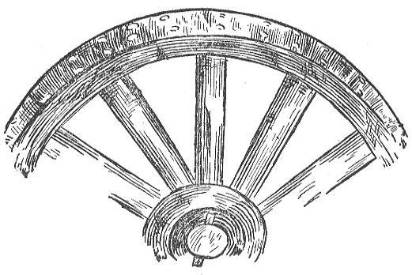

Broken Wheel Ranch POA
2026 Annual Meeting Proxy Form

August 13th, 7:00 p.m.
400 Aspen Ln., Alpine, WY 83128

Broken Wheel Ranch Property Owners Association
P.O. Box 3573
Alpine, WY 83128

I, _________________________________________________, owner of lot(s) ________________

hereby appoint ___________________________________, BWR Property Owner of lot(s) _______

to act as my proxy at the August 12th, 2025, POA Meeting.

_______________________________________ ______________________
Property Owner’s Signature Date

